**Department of Electrical Engineering**

|  |  |
| --- | --- |
| **Faculty Member: Dr. Ahmad Salman** | **Dated: 27/02/2023** |
| **Class/Section: BEE 12C** | **Semester: 6** |

**EE-330 Digital Signal Processing**

**Frequency Response and Nulling Filters**

|  |  |  |  |  |  |  |
| --- | --- | --- | --- | --- | --- | --- |
|  |  | **PLO4-CLO4** | | **PLO5-CLO5** | **PLO8-CLO6** | **PLO9-CLO7** |
| **Name** | **Reg. N** | **Viva /** | **Analysis** | **Modern Tool Usage** | **Ethics and Safety** | **Individual and Team Work** |
|  |  | **5 Marks** | **5 Marks** | **5 Marks** | **5 Marks** | **5 Marks** |
| **Hassan Rizwan** | **335753** |  |  |  |  |  |
| **M. Ahmed Mohsin** | **333060** |  |  |  |  |  |
| **Syeda Fatima Zahra** | **334379** |  |  |  |  |  |

Table of Contents

2 Objectives 4

3 Introduction 4

4 Frequency Response of FIR Filters 4

5 MATLAB Function for Frequency Response 5

5.1 Code 5

5.2 Output 6

6 Periodicity of the Frequency Response 6

7 Lab Task 1: Frequency Response of the Four-Point Average 6

7.1 INPUT: 7

8 Task 2.b 7

8.1 Code: 7

8.2 Output: 8

9 Task 2.c 9

9.1 Code: 9

9.2 Output: 10

10 The MATLAB FIND Function 11

10.1 Code 12

10.2 Output: 12

11 Cascading Two Systems 12

11.1 Part(a) 13

11.1.1 Code 13

11.1.2 Output 13

11.2 Part(B) 14

11.2.1 Code: 14

11.2.2 Output: 15

11.3 Part(c) 15

12 Lab Task 2 15

12.1 Part (A): 16

12.1.1 Code 16

12.1.2 Output 16

12.2 Part (b): 17

12.2.1 Code 17

12.2.2 Output 18

12.3 Part (c): 18

12.3.1 Code: 18

12.4 Part (d): 18

12.4.1 Code: 18

12.4.2 Formula: 18

12.5 Part (e): 19

12.5.1 Code: 19

12.5.2 Output 19

12.6 Part (f): 19

13 Conclusion 20

**Frequency Response and Pole Zero Plots of FIR/IIR Filters**

# Objectives

The goal of this lab is to study the response of FIR filters to inputs such as complex exponentials and sinusoids. In the experiments of this lab, you will use firfilt(), or conv(), to implement filters and freqz() to obtain the filter’s frequency response. As a result, you should learn how to characterize a filter by knowing how it reacts to different frequency components in the input

* Introduction to bandpass filters
* Introduction to Nulling filters
* Cascade systems and their frequency response
* How to extract information from sinusoidal signals

# Introduction

This lab also introduces two practical filters: bandpass filters and nulling filters. Bandpass filters can be used to detect and extract information from sinusoidal signals, e.g., tones in a touch-tone telephone dialer. Nulling filters can be used to remove sinusoidal interference, e.g., jamming signals in a radar.

# Frequency Response of FIR Filters

The output or *response* of a filter for a complex sinusoid input, $e^{j\hat{ω }n}$ depends on the frequency $\hat{ω}$ Often a filter is described solely by how it affects different input frequencies—this is called the *frequency response*. For example, the frequency response of the two-point averaging filter



can be found by using a general complex exponential as an input and observing the output or response.



In (3) there are two terms, the original input, and a term that is a function of $\hat{ω}$ This second term is the frequency response and it is commonly denoted by $H(e^{j\hat{ω }})$ which in this case is



Once the frequency response $H(e^{j\hat{ω }})$ has been determined, the effect of the filter on any complex exponential may be determined by evaluating $H(e^{j\hat{ω }})$ at the corresponding frequency. The output signal y[n], will be a complex exponential whose complex amplitude has a constant magnitude and phase. The phase describes the phase change of the complex sinusoid and the magnitude describes the gain applied to the complex sinusoid. The frequency response of a general FIR linear time-invariant system is In the example above, M = 1, and b0 = 1 /2 and b1 = 1/2 .

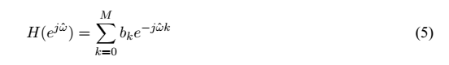

# MATLAB Function for Frequency Response

MATLAB has a built-in function called freqz() for computing the frequency response of a discrete-time LTI system. The following MATLAB statements show how to use freqz to compute and plot both the magnitude (absolute value) and the phase of the frequency response of a two-point averaging system as a function of $\hat{ω}$ in the range -pi to pi.

## Code

bb = [0.5, 0.5]; %-- Filter Coefficients

ww = -pi:(pi/100):pi; %-- omega hat

HH = freqz(bb, 1, ww);%<--freekz.m is an alternative

subplot(2,1,1);

plot(ww, abs(HH))

title('Magnitude Response');

subplot(2,1,2);

plot(ww, angle(HH))

title('Phase response');

xlabel('Normalized Radian Frequency');

## Output

# Periodicity of the Frequency Response

The frequency responses of discrete-time filters are *always* periodic with period equal to 2π.

then considering two input sinusoids whose frequencies are $\hat{ω}$ And $\hat{ω}$ + 2π.



Consult Chapter 6 for a mathematical proof that the outputs from each of these signals will be identical (basically because x1[n] is equal to x2[n].The implication of periodicity is that a plot of $H(e^{j\hat{ω }})$ only needs to extend over the interval or any other interval of length 2π.

# Lab Task 1: Frequency Response of the Four-Point Average

In class we examined filters that average input samples over a certain interval. These filters are called “running average” filters or “averages” and they have the following form for the L-point averager:



* Use Euler’s formula and complex number manipulations to show that the frequency response for the 4-point running average operator is given by:
* 

## INPUT:

# Task 2.b

Implement (7) directly in MATLAB. Use a vector that includes 400 samples between –π and π for $\hat{ω}$ Since the frequency response is a complex-valued quantity, use abs()and angle()to extract the Magnitude and phase of the frequency response for plotting. Plotting the real and imaginary parts of

$H(e^{j\hat{ω }})$ is not very informative.

## Code:

%% Task 2.b

w=-pi:pi/400:pi;

Hej=((2*cos(0.5*w)+2*cos(1.5*w))/4).*exp(-1i*1.5*w);

figure

plot(w,abs(Hej));

title('Magnitude Resposne');

figure

plot(w,angle(Hej));

title("phase Response");

## Output:

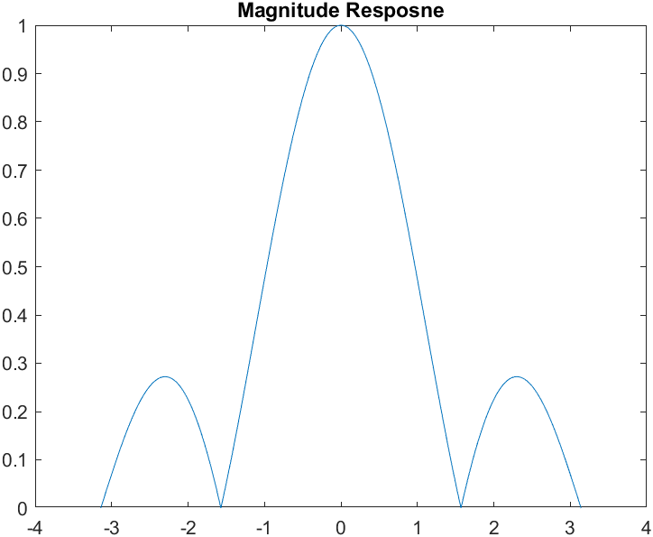

# Task 2.c

In this part, use freqz.m in MATLAB to compute $H(e^{j\hat{ω }})$ numerically (from the filter coefficients and plot its magnitude and phase versus $\hat{ω}$. Write the appropriate MATLAB code to plot both the magnitude and phase of $H(e^{j\hat{ω }})$ Follow the example in Section 8.1.2. The filter coefficient vector forthe 4-point averager is defined via:

*bb = 1/4*ones(1,4);*

## Code:

w=-pi:pi/400:pi;

bb = 1/4*ones(1,4);

H=freqz(bb,1,w);

figure

plot(w,abs(H));

title("Magnitude Response");

figure

plot(w,angle(H));

title("Phase Response");

## Output:

# The MATLAB FIND Function

Often signal processing functions are performed in order to extract information that can be used to make a decision. The decision process inevitably requires logical tests, which might be done with if-then constructs in MATLAB. However, MATLAB permits vectorization of such tests, and the find function is one way to do lots of tests at once. In the following example, find extracts all the numbers that “round” to 3:

xx = 1.4:0.33:5,

jkl = find(round(xx)==3),

xx(jkl)

The argument of the find function can be any logical expression. Notice that find returns a list of indices where the logical condition is true. See help on relop for information. Now, suppose that you have a frequency response:

ww = -pi:(pi/500):pi;

HH = freqz( 1/4*ones(1,4), 1, ww );

Use the find command to determine the indices where HH is zero, and then use those indices to display the list of frequencies where HH is zero. Since there might be round-off error in calculating HH, the logical test should probably be a test for those indices where the magnitude (absolute value in MATLAB) of HH is less than some rather small number, e.g., 1 × 10−6. Compare your answer to the frequency response that you plotted for the four-point average in Section 8.1.4.

## Code

w=-pi:pi/400:pi;

Hej=((2*cos(0.5*w)+2*cos(1.5*w))/4).*exp(-1i*1.5*w);

figure

plot(w,abs(Hej));

title('Magnitude Resposne');

figure

plot(w,angle(Hej));

title("phase Response");

%% Task 2.c

w=-pi:pi/400:pi;

bb = 1/4*ones(1,4);

H=freqz(bb,1,w);

figure

plot(w,abs(H));

title("Magnitude Response");

figure

plot(w,angle(H));

title("Phase Response");

%% Task FIND function

mag_zero=find(abs(Hej)<1e-6);

## Output:

mag_zero =

1 201 601 801

# Cascading Two Systems

More complicated systems are often made up from simple building blocks. In Fig. 2, two FIR filters are shown connected “in cascade.”



## Part(a)

Use freqz() in MATLAB to get the frequency responses for the case where α = 0.8 and M = 9.Plot the magnitude and phase of the frequency response for Filter #1, and also for Filter #2. Which one of these filters is a *lowpass filter*?

### Code

n=0:9;

a=0.8;

b1=a.^n;

w=-pi:pi/400:pi;

H1=freqz(b1,1,w);

figure

plot(w,abs(H1));

title("Magnitude Response");

figure

plot(w,angle(H1));

title("Phase Response");

n=0:9;

a=0.8;

b1=a.^n;

w=-pi:pi/400:pi;

H1=freqz(b1,1,w);

figure

plot(w,abs(H1));

title("Magnitude Response");

figure

plot(w,angle(H1));

title("Phase Response");

%

% defining second fucntion

b2=[1,-a,zeros(1,8)];

H2=freqz(b2,1,w);

figure

plot(w,abs(H2));

title("Magnitude Response");

figure

plot(w,angle(H2));

title("Phase Response");

### Output

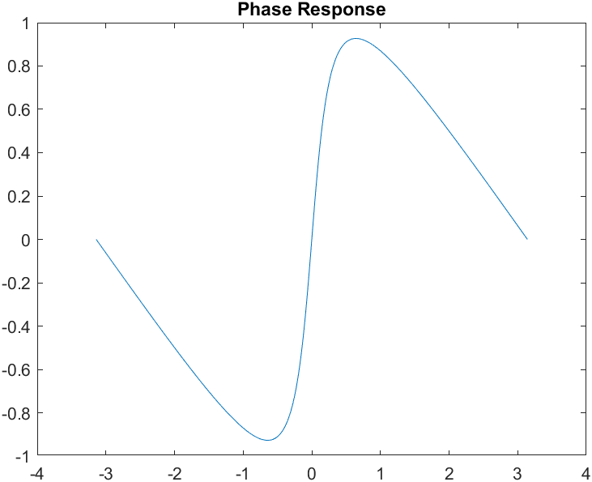

## Part(B)

Plot the magnitude and phase of the frequency response of the overall cascaded system.

### Code:

Overall_resp = H1.*H2;

figure

subplot(2, 1, 1);

plot(w, abs(Overall_resp))

title('Magnitude Response')

grid

subplot(2, 1, 2);

plot(w, angle(Overall_resp))

title('Phase Response')

xlabel('Normalized Frequency')

grid

### Output:

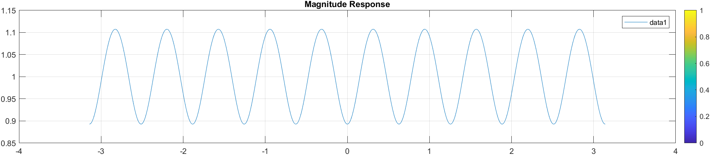

## Part(c)

Explain how the individual frequency responses in part(a) are combined to get the overall frequency response in part(b). Comment on the magnitude combinations as well as the phase combinations.

The arrangement of Filter 1 and Filter 2 can be described as a series, or cascade, where the frequencies of each filter are multiplied to produce the combined response of the entire system. This overall response can be derived by performing a convolution in the time domain, which is equivalent to multiplication in the frequency domain, using the impulse response of Filter 1 and Filter 2.

# Lab Task 2

Nulling filters are filters that completely eliminate some frequency component. If the frequency is $\hat{ω}$ = 0 or $\hat{ω}$ = π, then a two-point FIR filter will do the nulling. The simplest possible general nulling filter can have as few as three coefficients. If $\hat{ω}$ is the desired nulling frequency, then the following length-3 FIR filter.



## Part (A):

Design a filtering system that consists of the cascade of two FIR nulling filters that will eliminate the following input frequencies: 𝜔̂ = 0.44π, and 𝜔̂ = 0.7π. For this part, derive the filter coefficients of both nulling filters.

### Code

% Define the filter coefficients

b1 = [1, -2*cos(0.44*pi), 1];

b2 = [1, -2*cos(0.7*pi), 1];

% Compute the combined filter coefficients

b = conv(b1, b2);

% Define the frequency vector

w = linspace(-pi, pi, 401);

% Compute the frequency response of the filter

H = freqz(b, 1, w);

% Plot the magnitude response

subplot(2, 1, 1);

plot(w, abs(H));

title('Magnitude Response');

xlabel('Normalized Radian Frequency');

ylabel('Magnitude');

grid on;

% Plot the phase response

subplot(2, 1, 2);

plot(w, angle(H));

title('Phase Response');

xlabel('Normalized Radian Frequency');

ylabel('Phase (radians)');

grid on;

### Output

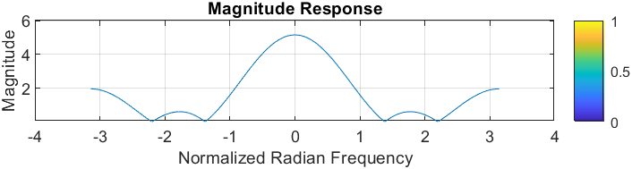

## Part (b):

Generate an input signal x[n] that is the sum of three sinusoids:



Make the input signal 150 samples long over the range 0 < n < 149.

### Code

% Define the filter coefficients

b1 = [1, -2*cos(0.44*pi), 1];

b2 = [1, -2*cos(0.7*pi), 1];

% Compute the combined filter coefficients

b = conv(b1, b2);

% Define the frequency vector

w = -pi:(pi /150):pi;

% Compute the frequency response of the filter

H = freqz(b, 1, w);

% Plot the magnitude response

subplot(2, 1, 1);

plot(w, abs(H));

title('Magnitude Response');

xlabel('Normalized Radian Frequency');

ylabel('Magnitude');

grid on;

### Output

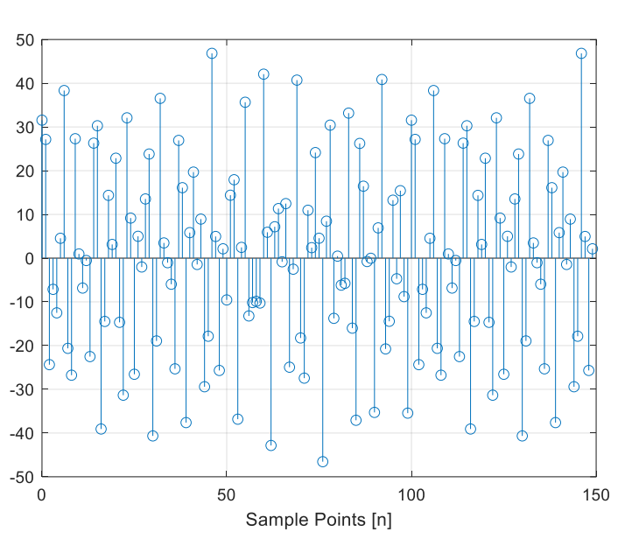

## Part (c):

Use filter to filter the sum of three sinusoids signal x[n] through the filters in part (a).

### Code:

y = filter(b, 1, x);

## Part (d):

Make a plot of the output signal—show the first 40 points. Determine (by hand) the exact mathematical formula (magnitude, phase, and frequency) for the output signal for n ≥ 5.

### Code:

n=0:1:150;

y=10.*cos(0.3*pi*(n+3));

figure

stem(n,y);

### Formula:

y[𝑛] = 10cos (0.3𝜋(𝑛 + 3))

## Part (e):

### Code:

%%

n=0:1:150;

y=10.*cos(0.3*pi*(n+3));

figure

stem(n,y);

xlabel("Sample points");

ylabel("Stem Output");

### Output

## Part (f):

Explain why the output signal is different for the first few points. How many “start-up” points are found, and how is this number related to the lengths of the filters designed in part (a)? Hint: consider the length of a single FIR filter that is equivalent to the cascade of two length-3 FIRs.

The initial response of the output signal is subject to variation owing to the start-up transient. When we cascade two Finite Impulse Response (FIR) filters, the total length of the resulting filter is equal to the sum of the lengths of the individual filters, decreased by one. In our present scenario, each filter has a length of 3, therefore, the cascaded filter has a length of 5. Due to the overall length of the filter being 5, the initial conditions of the filter impact the first 4 data points, resulting in an altered output.

# Conclusion

During this laboratory session, we delved into the behavior of Finite Impulse Response (FIR) filters when exposed to various input signals, such as complex exponentials and sinusoids. Our study enabled us to comprehend how to define a filter's characteristics based on its frequency response and how to construct and execute bandpass and Nulling filters. Furthermore, we examined the notion of cascade systems, exploring how to scrutinize their frequency response in detail.